**TITLE OF LAB: (INTRODUCTION TO COMPLEX NUMBERS)**

**LAB # 05**



**Spring 2022**

**CSE301L Signals & Systems Lab**

Submitted by: **Safi Ullah Khan**

Registration No.: **20PWCSE1943**

Class Section: **B**

“On my honor, as student of University of Engineering and Technology, I have neither given nor received unauthorized assistance on this academic work.”

Student Signature: ______________

Submitted to:

**Engr. Durr-e-Nayab**

Day, Date (e.g Sunday, Jun 05th, 2022)

**Department of Computer Systems Engineering**

**University of Engineering and Technology, Peshawar**

**OBJECTIVES OF THE LAB**

‐‐‐‐‐‐‐‐‐‐‐‐‐‐‐‐‐‐‐‐‐‐‐‐‐‐‐‐‐‐‐‐‐‐‐‐‐‐‐‐‐‐‐‐‐‐‐‐‐‐‐‐‐‐‐‐‐‐‐‐‐‐‐‐‐‐‐‐‐‐‐‐‐‐‐‐

In this lab, we will cover the following topics:

* **Gain familiarity with Complex Numbers and plot them**
* **Complex exponential signals**
* **Real exponential signals**

‐‐‐‐‐‐‐‐‐‐‐‐‐‐‐‐‐‐‐‐‐‐‐‐‐‐‐‐‐‐‐‐‐‐‐‐‐‐‐‐‐‐‐‐‐‐‐‐‐‐‐‐‐‐‐‐‐‐‐‐‐‐‐‐‐‐‐‐‐‐‐‐‐‐‐‐

**-------------------------TASK 01--------------------------**

* Write matlab function **zprint,** which takes a complex number and returns it real part, imaginary part, magnitude, phase in radians, and phase in degrees.

**Screenshot of Input:**

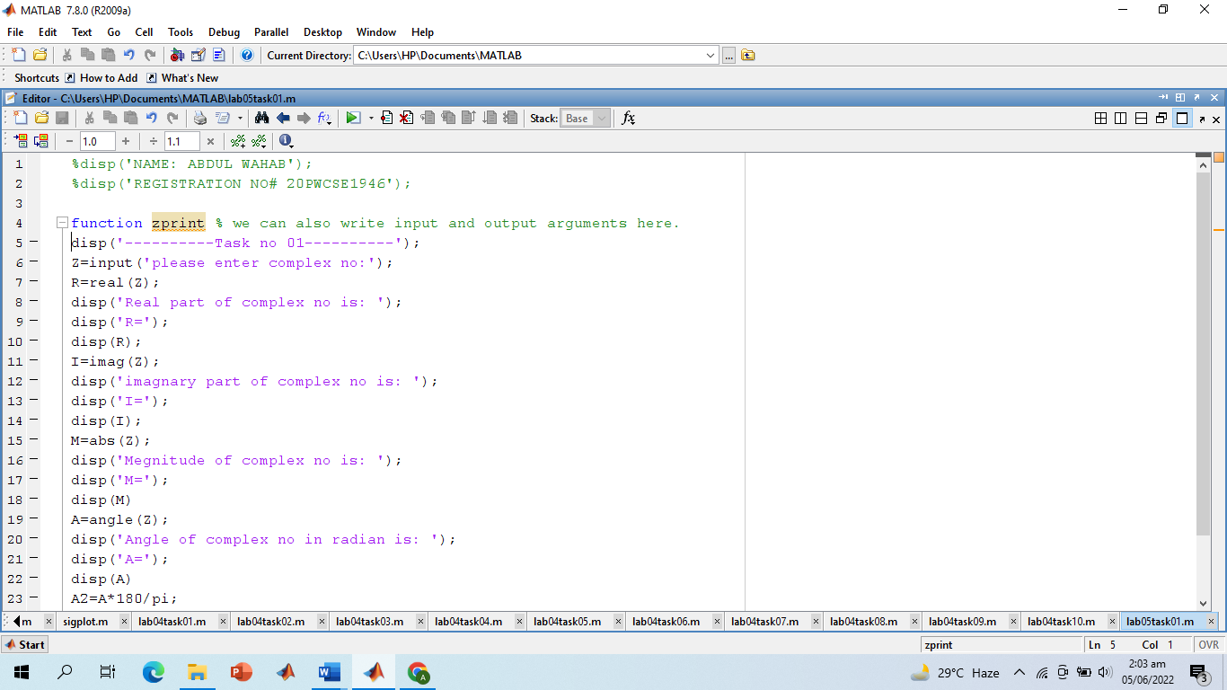

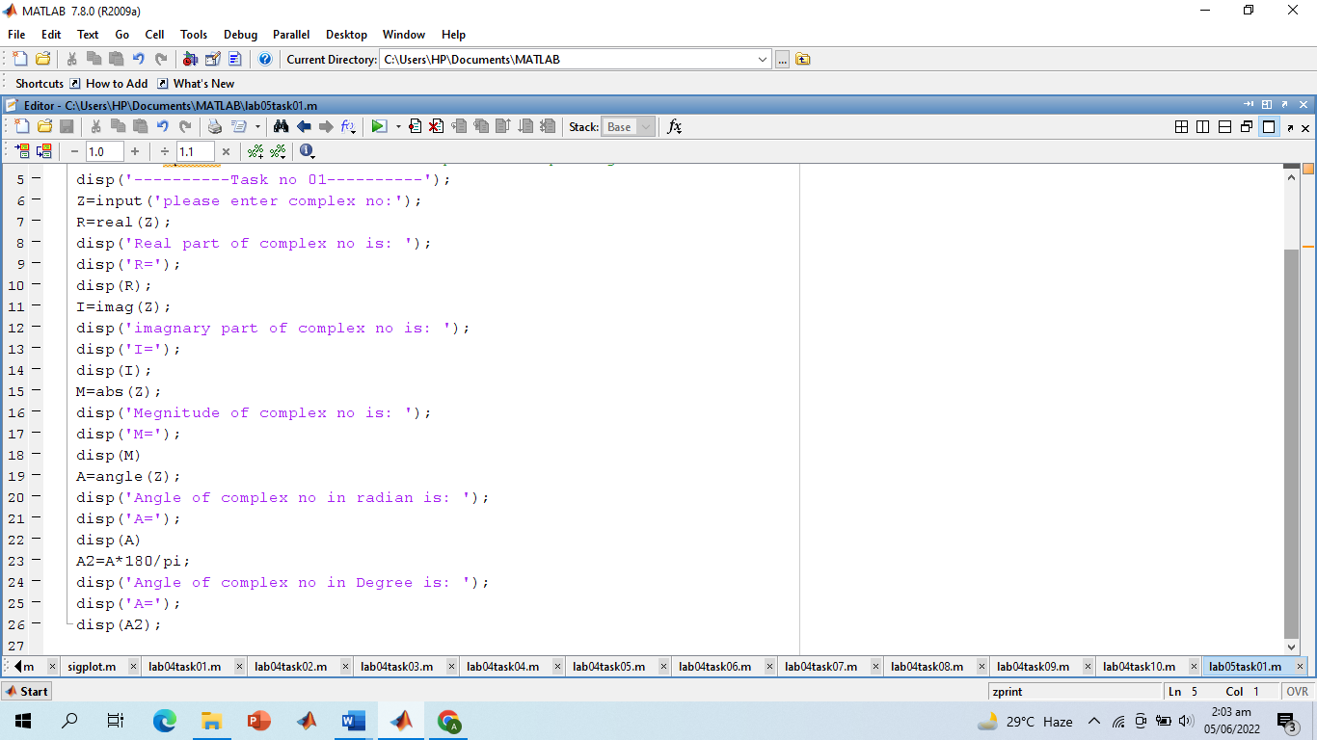

**Screenshot of Output:**

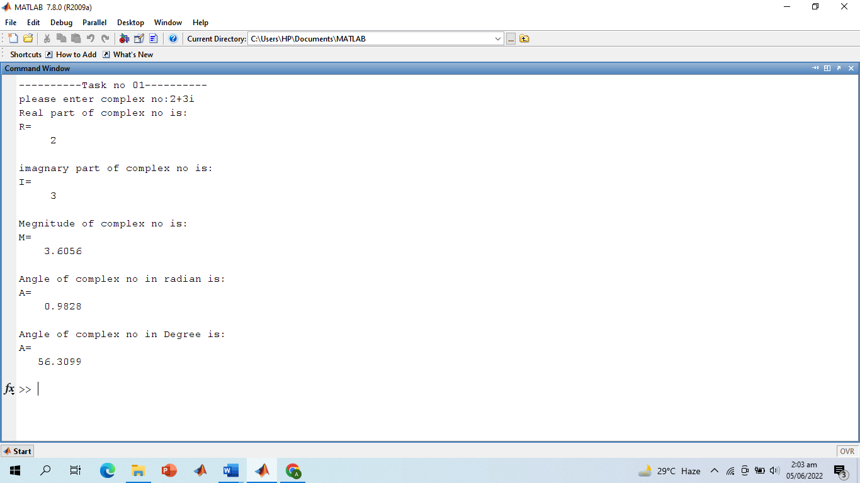

**-------------------------TASK 02--------------------------**

Compute the conjugate ź (i.e., z_conj [give variable name]) and the inverse 1/z (i.e., z_inv [give variable name]) for any complex number z. Display the results numerically with zprint.

**Screenshot of Input:**

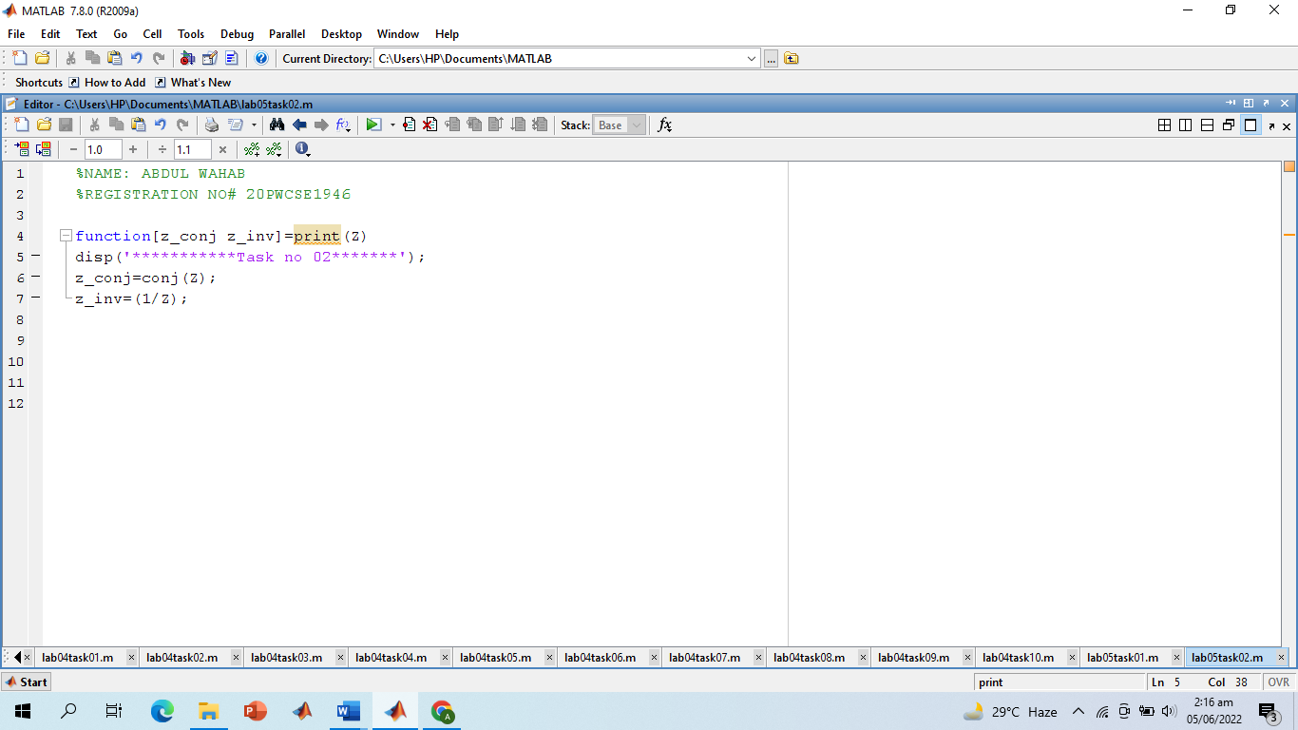

**Screenshot of Output:**

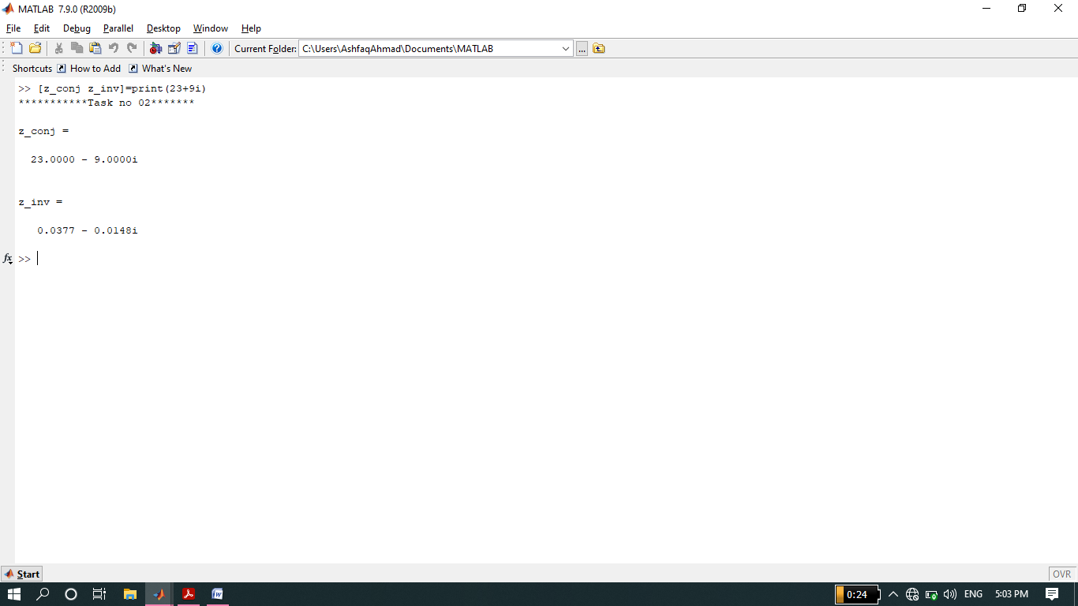

**-------------------------TASK 03--------------------------**

* Take two complex number and compute z1 +z2 and display the results numerically using zprint.

**Screenshot of Input:**

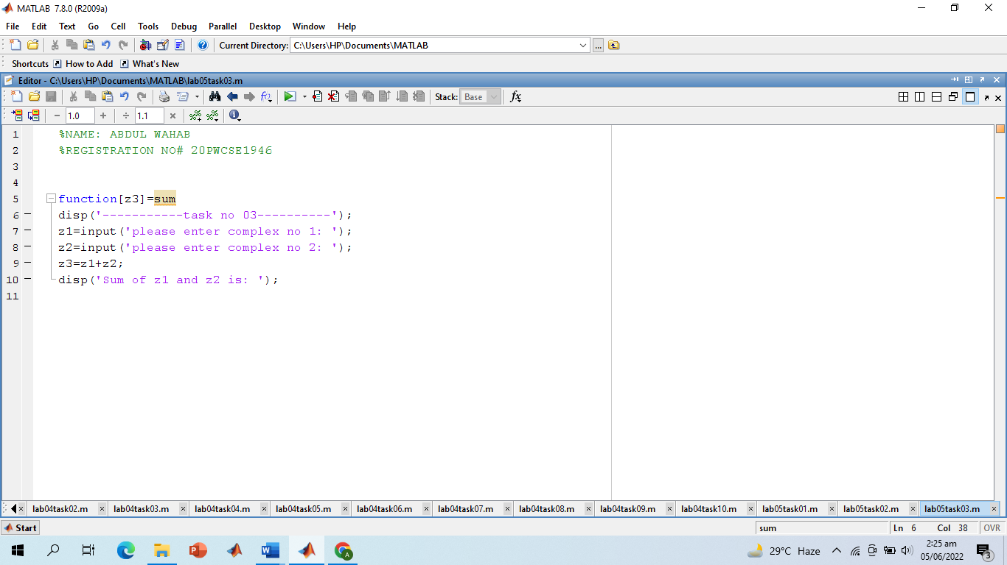

**Screenshot of Output:**

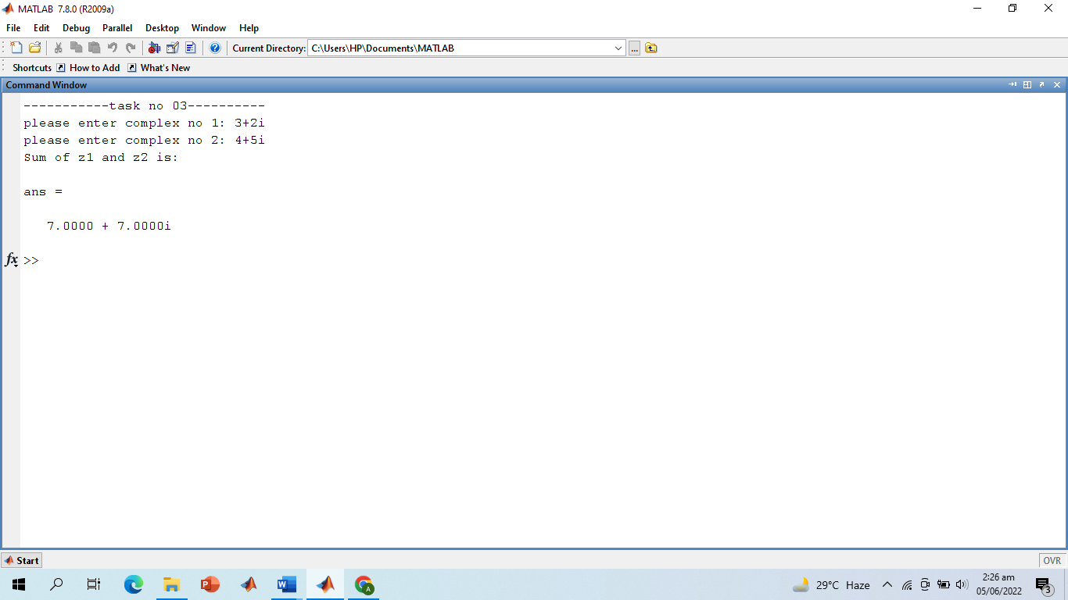

**-------------------------TASK 04--------------------------**

* Take two complex numbers and compute z1z2 and z1/z2. Use zprint to display the results numerically.

**Screenshot of Input:**

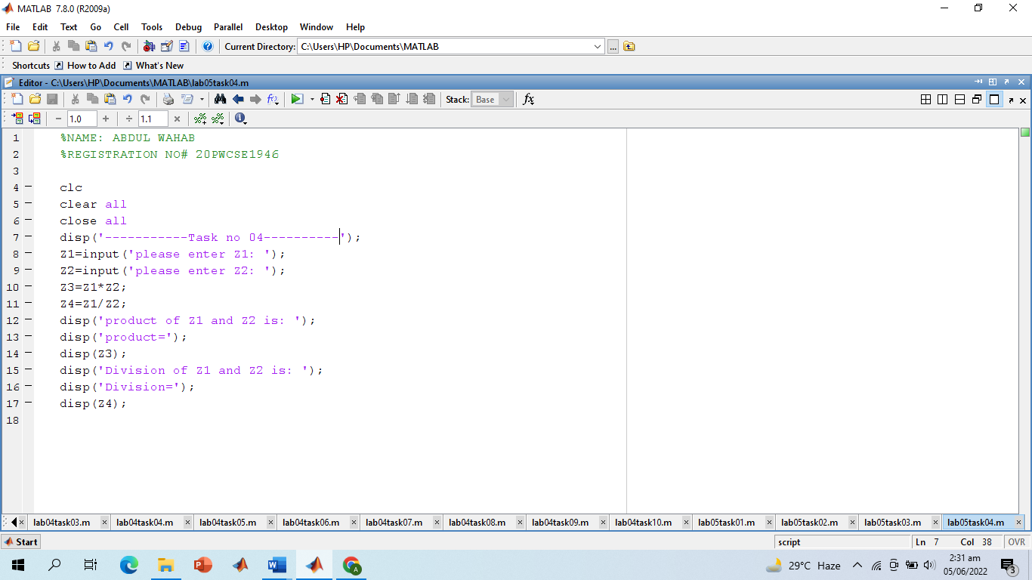

**Screenshot of Output:**

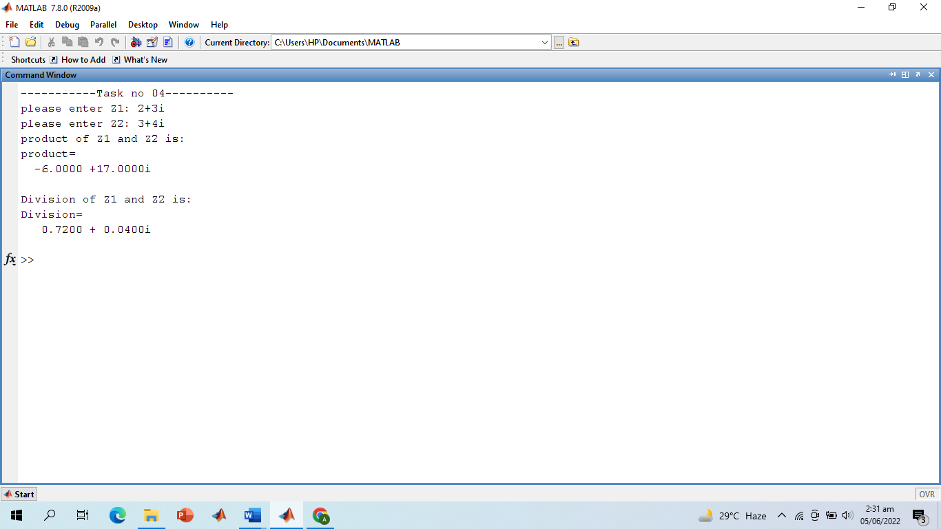

**-------------------------TASK 05--------------------------**

* Determine the complex conjugate of the exponential signal given in above example and plot its real and imaginary portions.

**Screenshot of Input:**

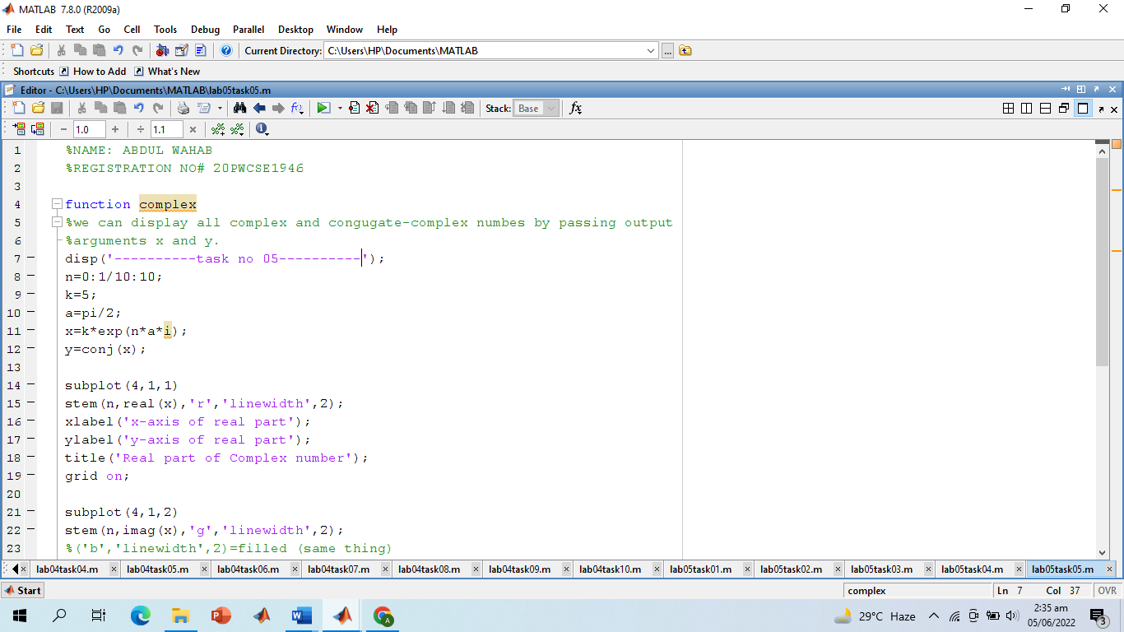

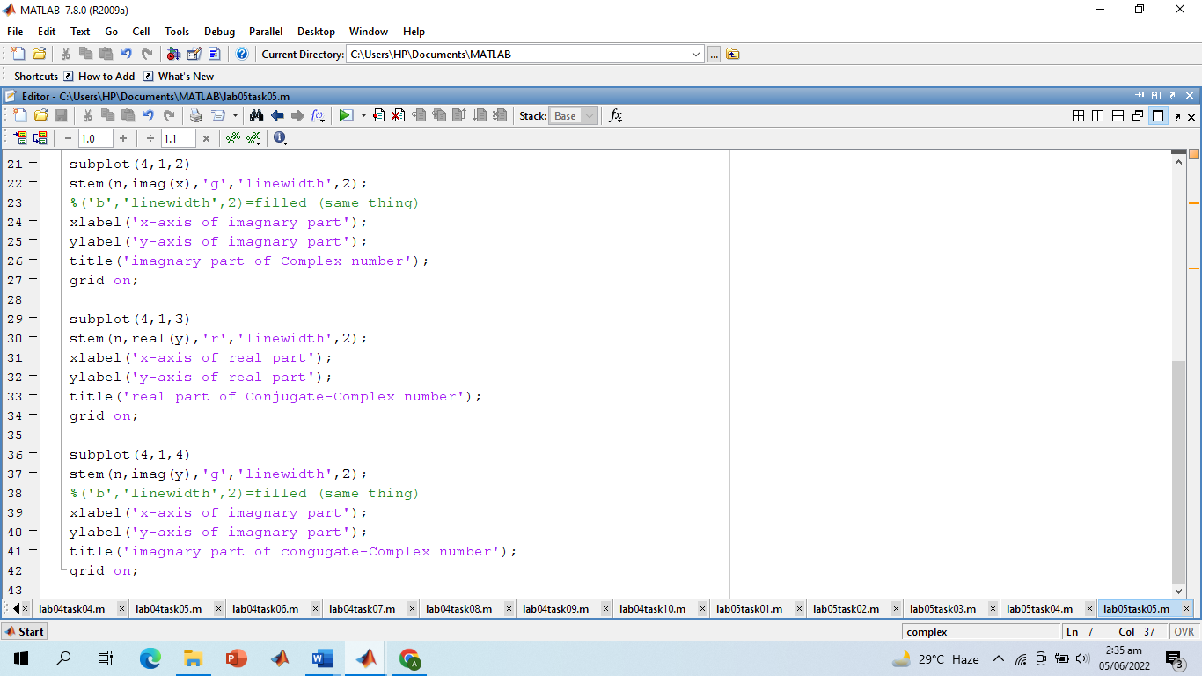

**Screenshot of Output:**

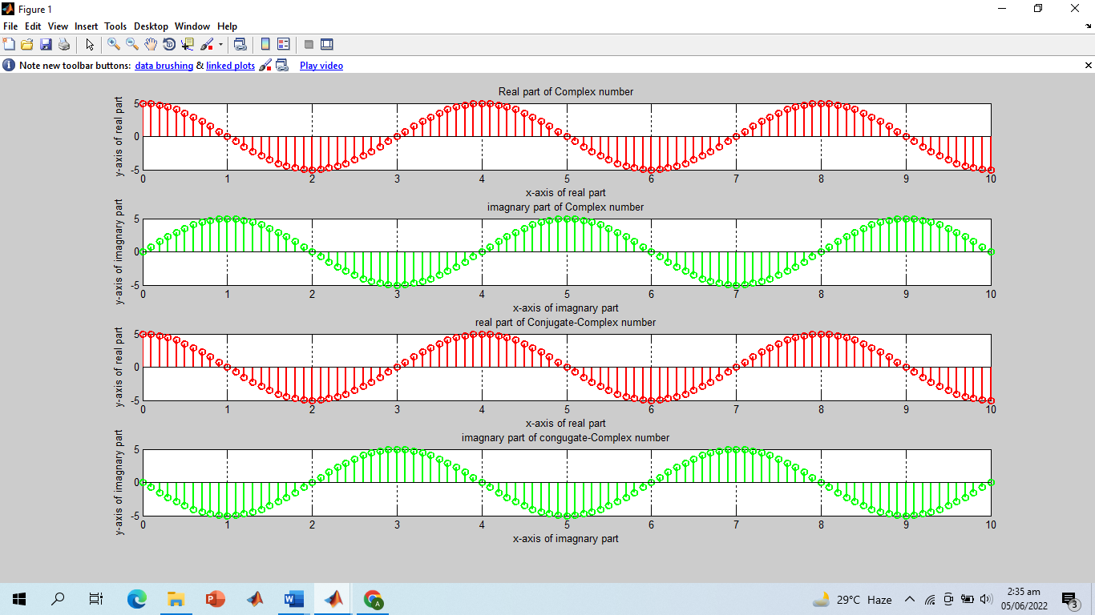

**-------------------------TASK 06--------------------------**

* Generate the complex valued signal and plot its magnitude, phase, the real part, and the imaginary part in separate subplots.
  + y(n) = exp (-0.2 + j0.5n), ‐10≤n≤10

**Screenshot of Input:**

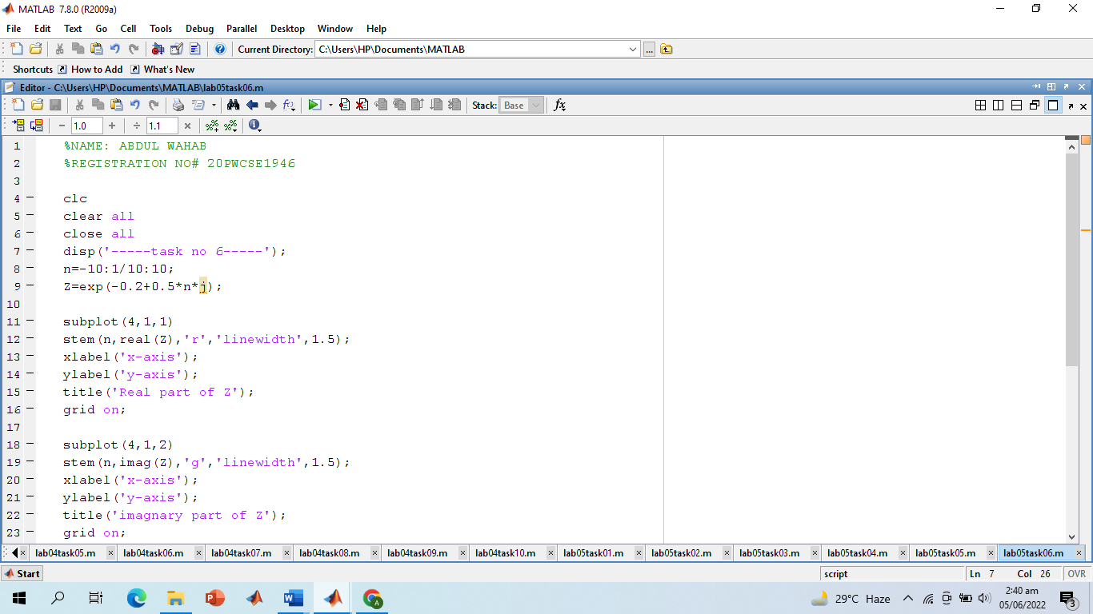

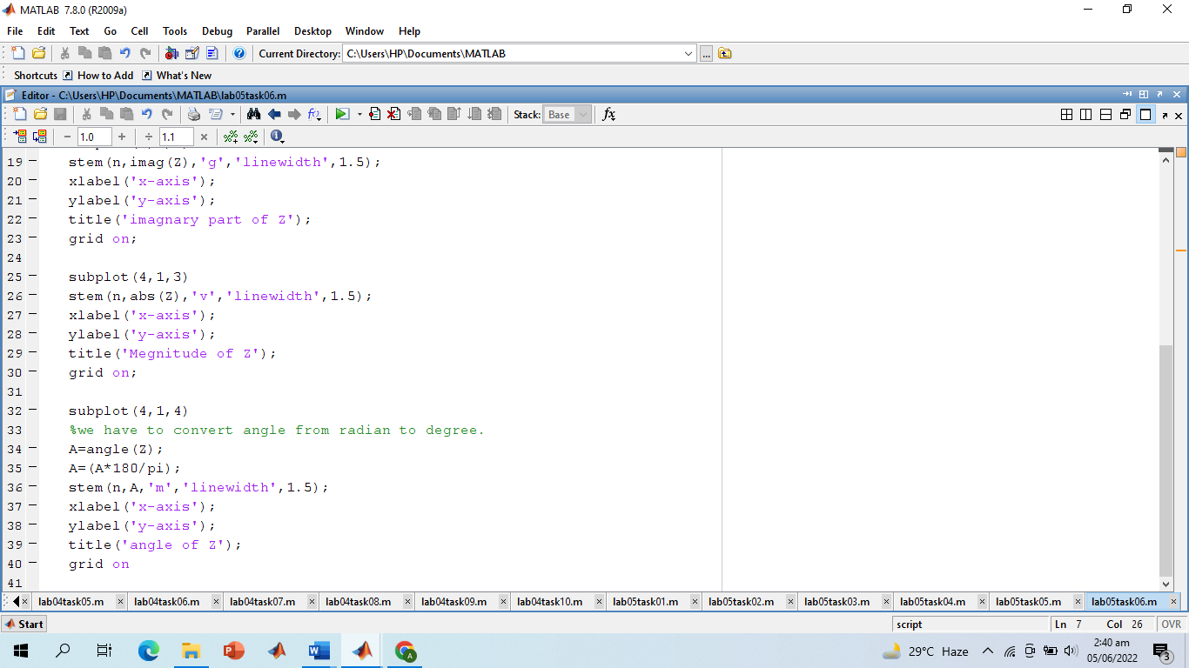

**Screenshot of Output:**

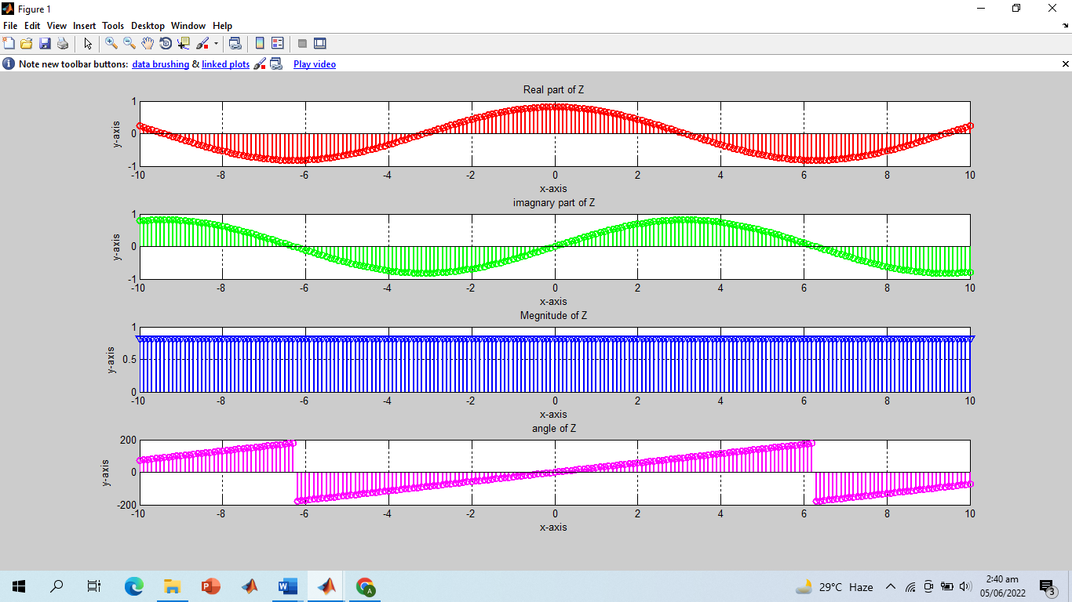

**-------------------------TASK 07--------------------------**

a) Generate a real‐exponential x=a * exp(n) for a=0.7 and n ranging from 0‐10. Find the discrete time as well as the continuous time version of this signal. Plot the two signals on same graph (holding both the graphs).

b) Repeat the same program with value of a=1.3.

**Screenshot of Input:**

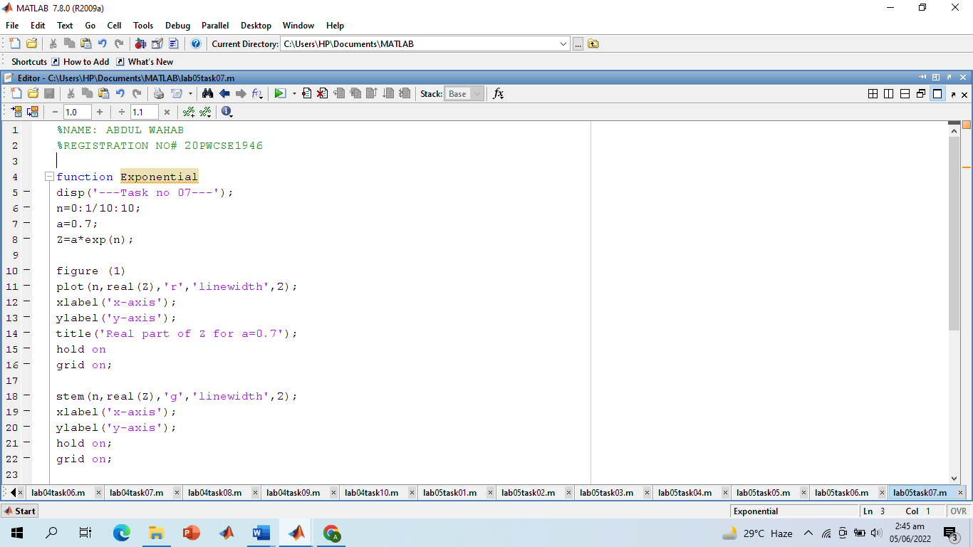

**Screenshot of Output Part (a):**

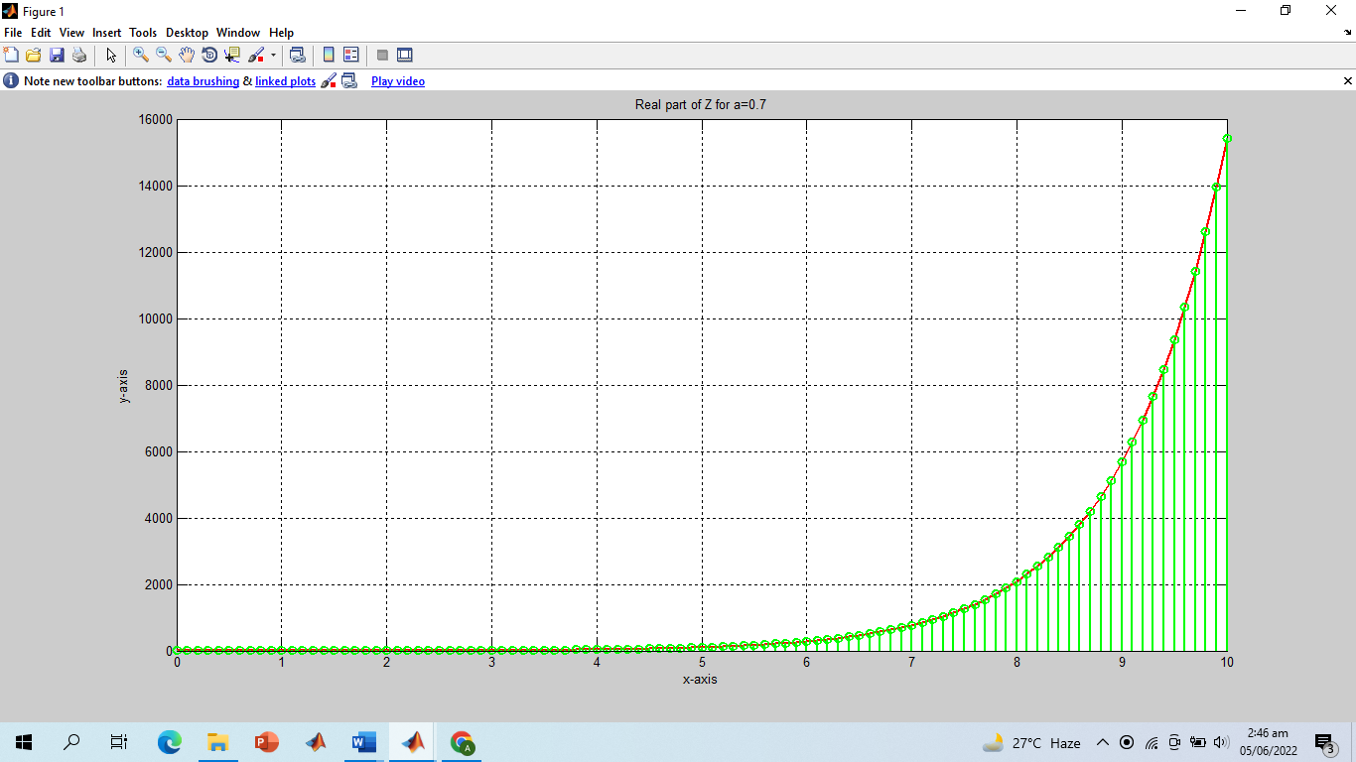

**Screenshot of Output Part (b):**

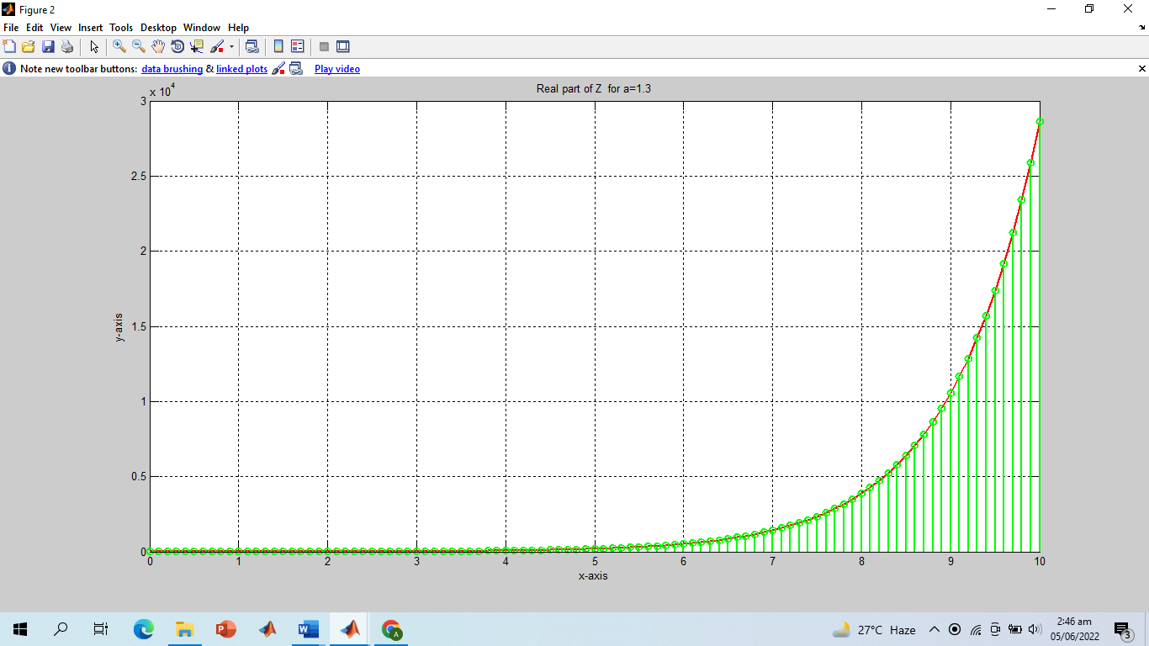

**-------------------------TASK 08--------------------------**

* Multiply the two discrete signals x1=5 exp (i*n*pi/4) and x2= a * exp(n) (use point‐by‐point multiplication of the two signals). Plot the real as well as the imaginary parts for 0<a<1 and a>1.

**Screenshot of Input:**

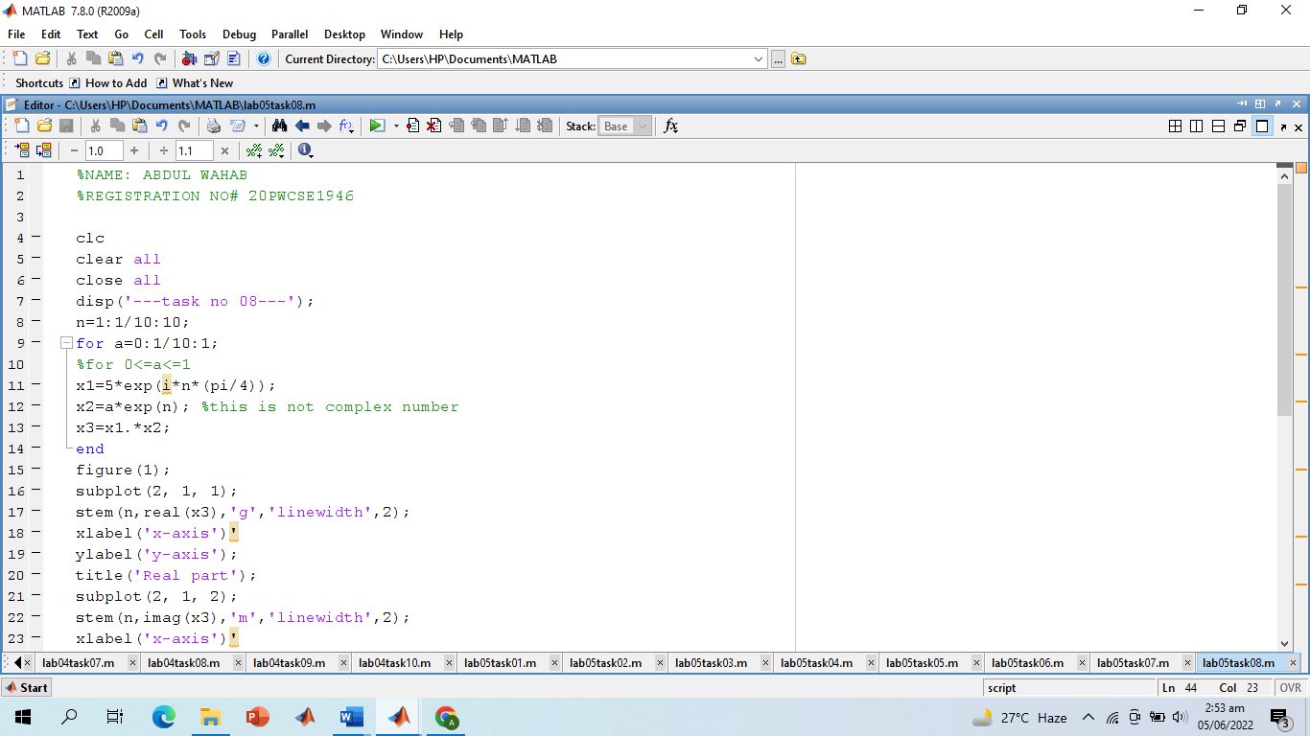

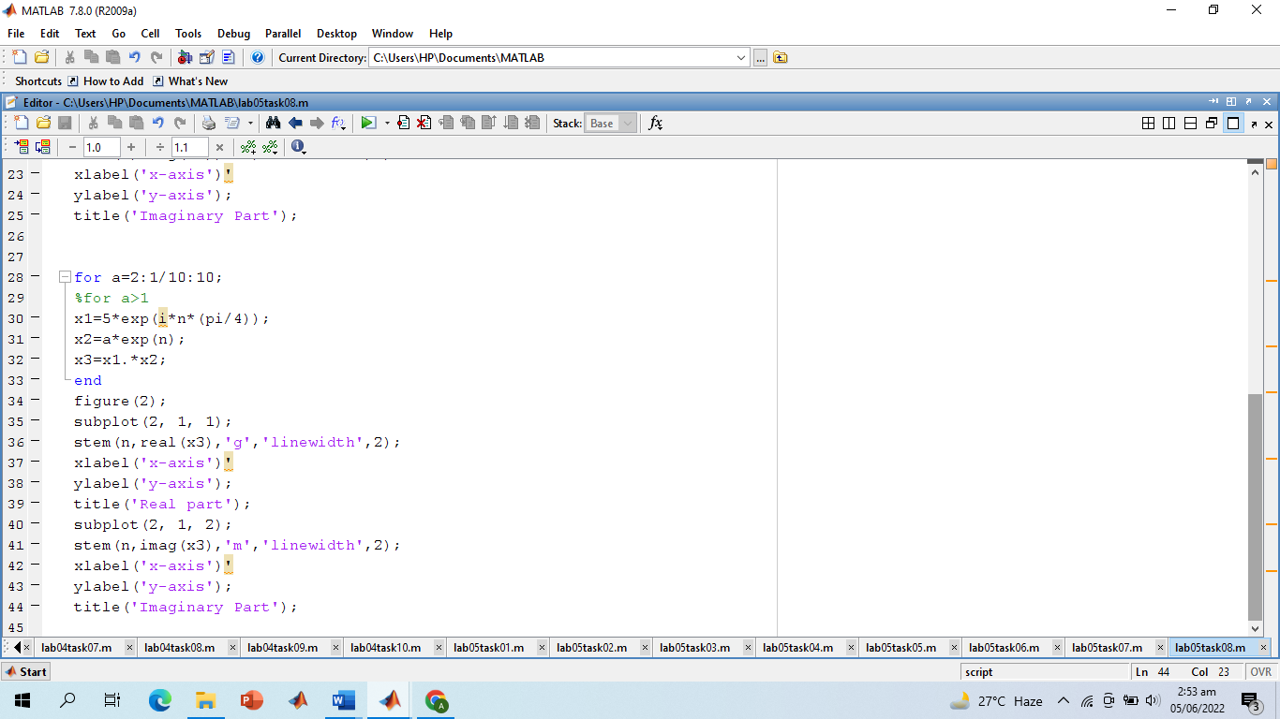

**Screenshot of Output:**

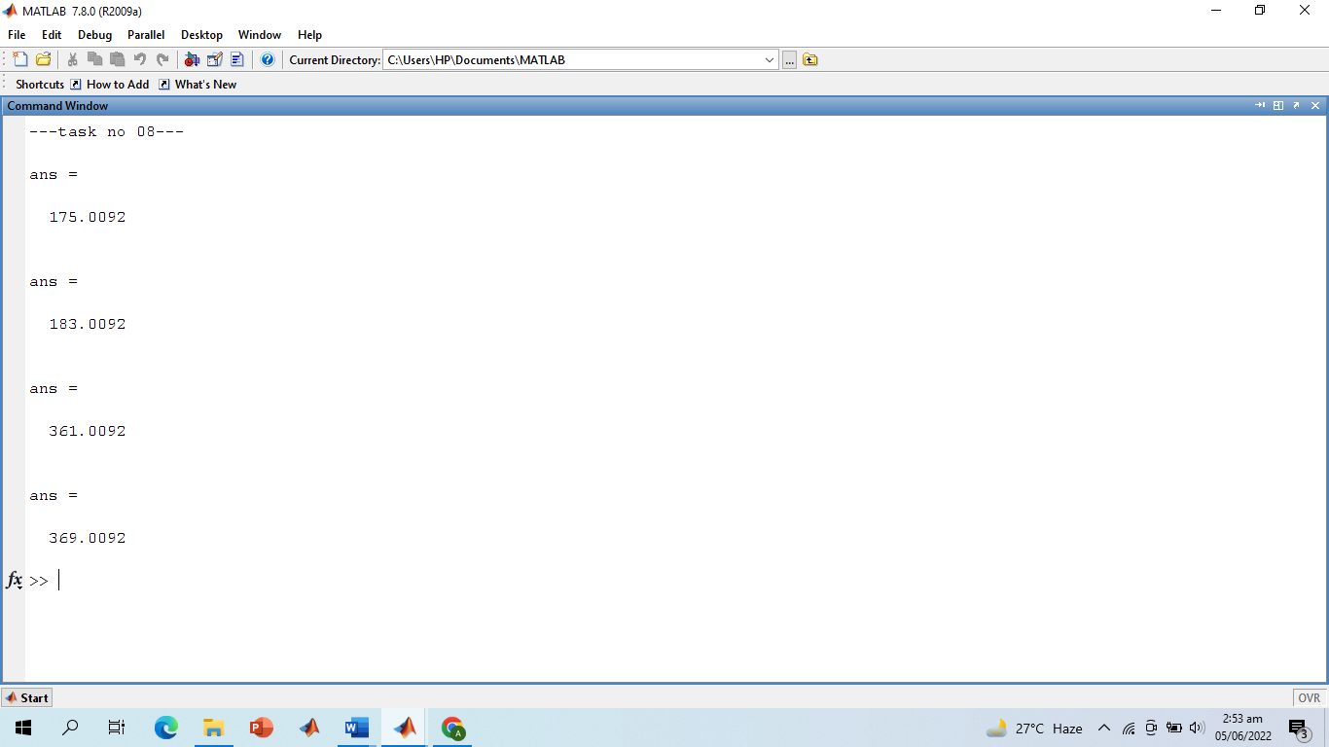

**Screenshot of Output:**

**For 0<=1<=1:**

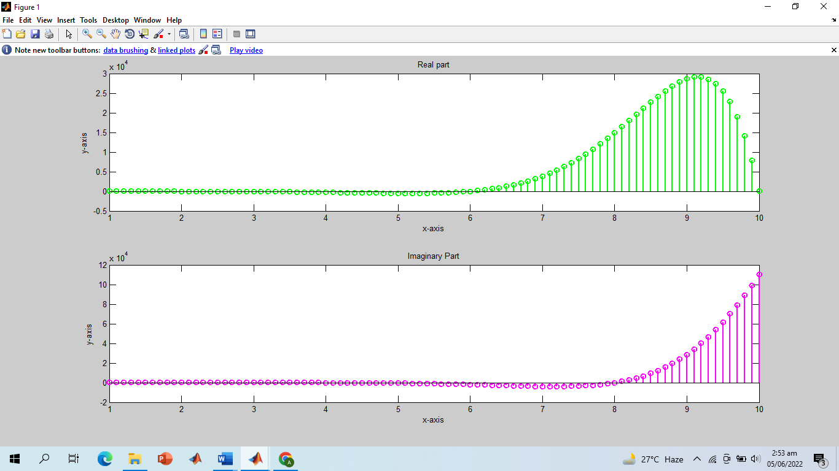

**Screenshot of Output:**

**For a>1:**

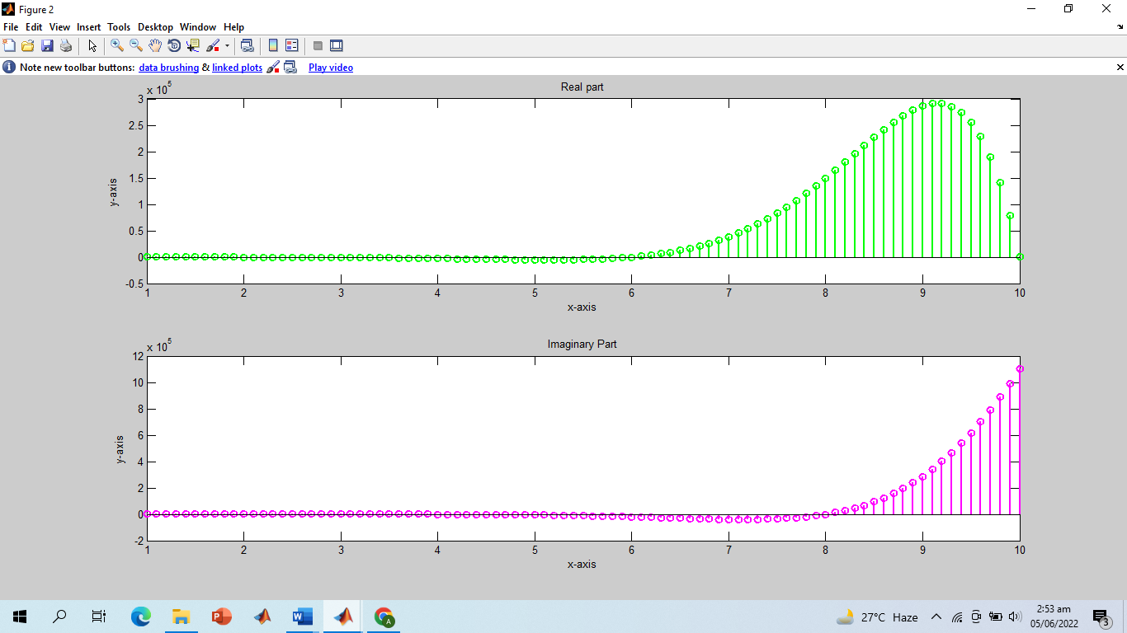

**-------------------------TASK 09--------------------------**

* Plot the discrete signal x=a^|n| for n ranging from ‐10 to 10. Draw two subplots for 0<a<1 and a>1.

**Screenshot of Input:**

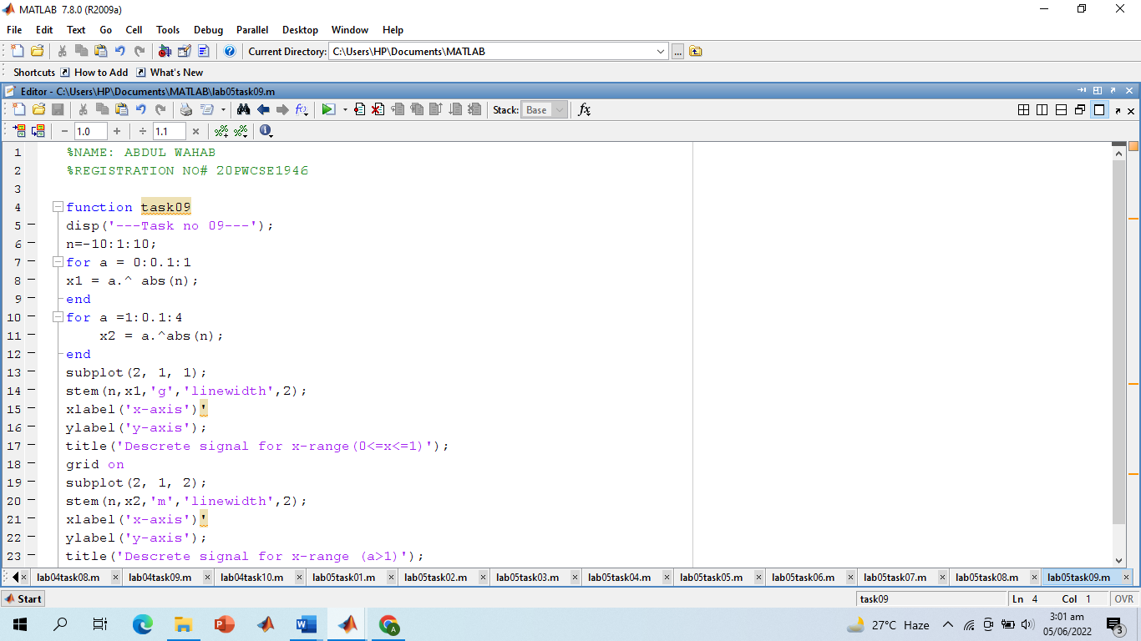

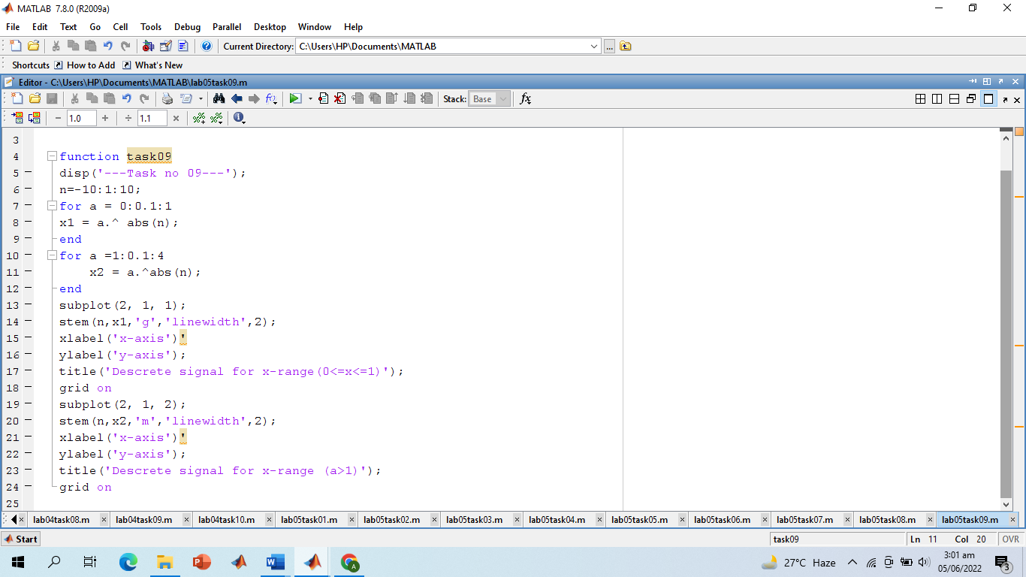

**Screenshot of Output:**

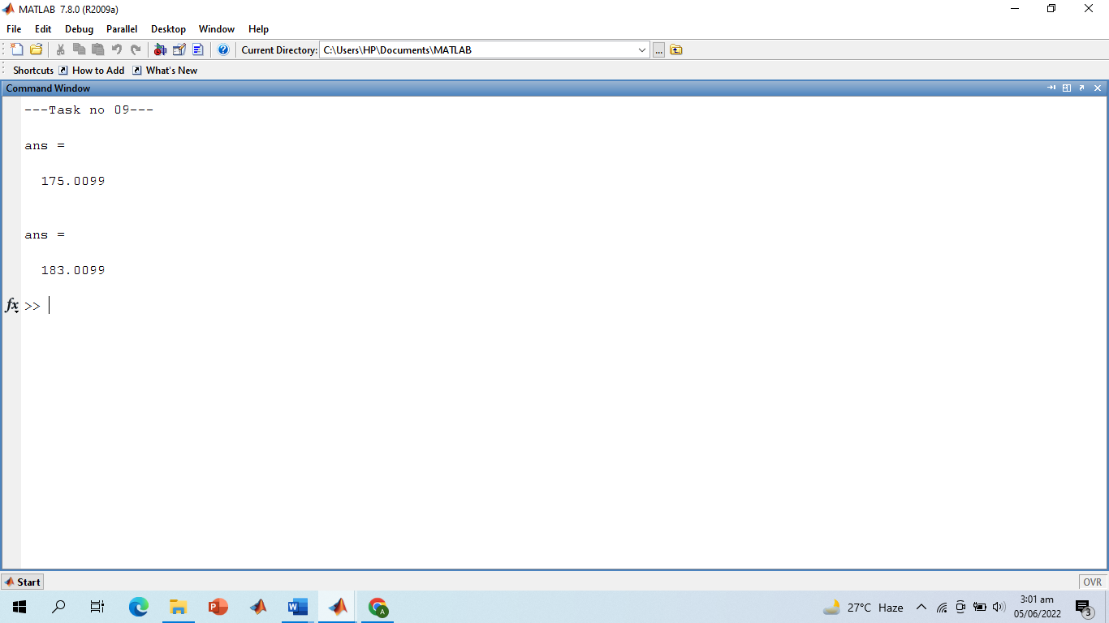

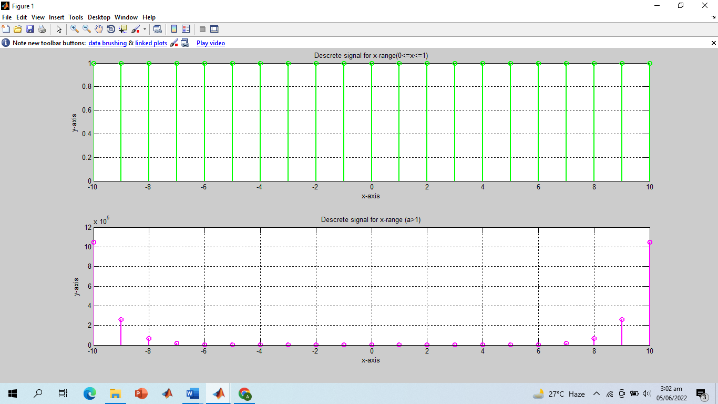

**-------------------------TASK 10--------------------------**

1. Generate the signal x(t) = Ae(jωt + π) for A = 3, π= ‐0.4, and ω = 2π(1250). Take a range for t that will cover 2 or 3 periods.
2. Plot the real part versus t and the imaginary part versus t. Use subplot(2,1,i) to put both plots in the same window.
3. Verify that the real and imaginary parts are sinusoids and that they have the correct frequency, phase, and amplitude.

**Screenshot of Input:**

**Part (a):**

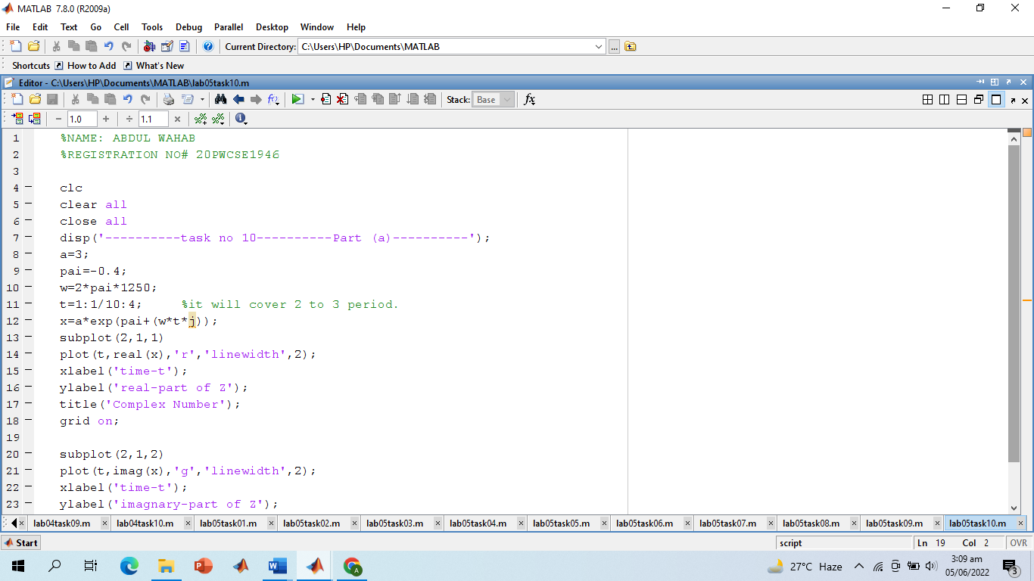

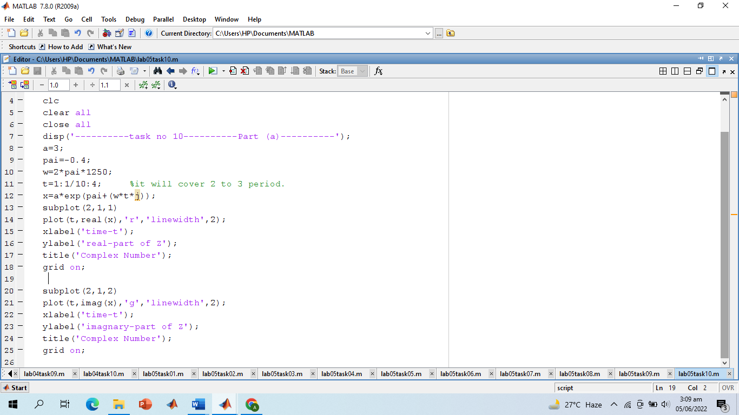

**Screenshot of Output:**

**Part (b):**

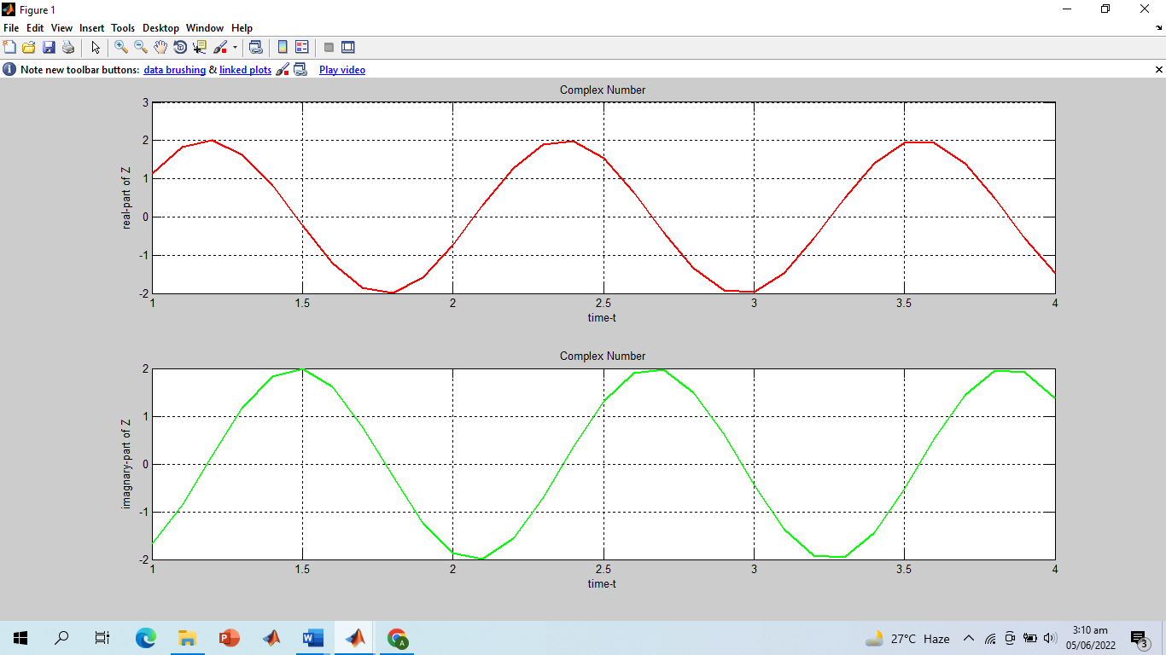

**Part (c):**

* Thus, it is verified that both imaginary and real part are sinusoid and have the correct frequency, phase, and amplitude.

**-------------------------THE END--------------------------**